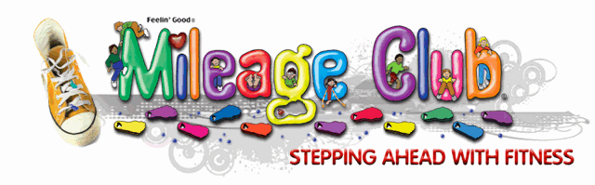
Alamosa Park Running Club

Grades 2-5 (400 students)
Grades 1-5 (500 students)

A running club at Alamosa Park would build active living, improve learning readiness, fight obesity and provide an excellent award for students.

Children run or walk around the perimeter of the grass field area 2 – 3 times a week. Teachers track student progress by making tally marks on index cards each time they complete a lap. Students return cards to teachers each day after running.

For every 5 miles (25 laps) a child runs, the child is rewarded with a Toe Token (brightly colored plastic feet). They continue to run starting a new index card and a goal of reaching another 5 miles. The Toe Token is a great way to provide children with a sense of accomplishment. In 1-5 grades students are motivated to “GET FIT.” As the students earn more and more Toes they build muscles, burn calories, reduce stress, strengthen physical fitness habits, and have fun.

In addition to the Token Toes, students are rewarded with a Marathon Medal after running 26.2 miles. Additional numbers are available for students that reach 50 miles, 75 miles and even 100 miles. Tokens are worn on chains and can be awarded to students in individual classrooms.

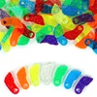
There are several other tokens that can be used as rewards like runners, walkers, medals, etc. All could be purchased as mile markers instead of just using the numbers 50, 75, and 100.

Cost of program –

- Chains - silver chains .37 cents / colored chains .59 cents
500 x .37 = $185 500 x .59 = $295
Extra chains would need to be purchased if lost, stolen, or broken

- Token Toes – average of 10-20 toes per student.
-always good to have extra and they can roll over to the next year
1000 toes basic colors $59.95
15 toes x 500 students = 7500 toes
8000 toes = $479.60

- Mileage Awards - Marathon medals – 26.2 miles
Bag of 500 = $73.95

Additional mileage awards – 50 miles – runner award
Bag of 250 = $26.95

Additional mileage award – 75 miles – sneaker award
Bag of 250 = $26.95

Additional mileage award – 100 miles – mini medal or the number 100
Bag of 250 = $28.95

Estimated total cost of program for grades 1-5 = $821.40 (with silver chains)
= $931.40 (with colored chains)

Approximately $1.65 per student to participate in the program

Leslie Manwaring Alamosa Park Elementary 3rd Grade

